Case 4-A89-ME-Phoenicia-Glass-Jar-Amulet-100 BCE
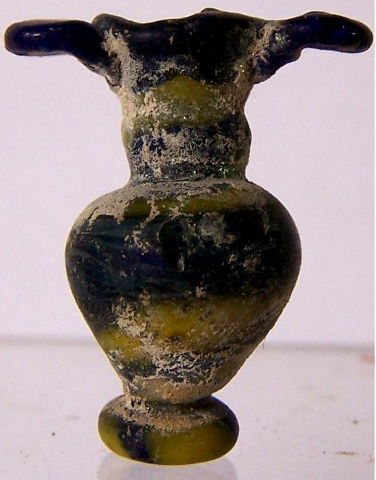

Case no.:4
Accession Number: A89
Formal Label: ME-Phoenicia-Glass-Amulet jar
Display Description: Ṣīḏōn (Σιδών' “fishing-town”. In Roman times, Sidon was an entrepreneurial town that was famous for its manufactures and arts, as well as for its commerce (1 Kings 5:6; 1 Chronicles 22:4; Ezekiel 27:8). that produced fine glass such as this diminutive amulet jar displaying the Phoenician penchant for glassblowing techniques that mixed two or more colors.
LC Classification: NK4017.2.P65
Date or Time Horizon: 100 BCE
Geographical Area: Sidon
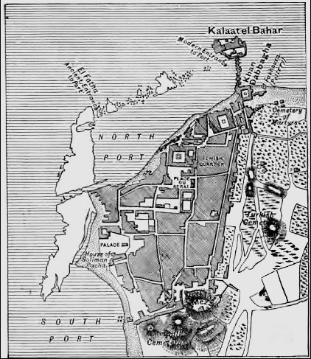
Map from http://www.bible-history.com/ibh/images/fullsized/plan-of-sidon.jpg
GPS coordinates: 33°33′38″N 35°23′53″E
Cultural Affiliation: Sidonian, Phoenician
Media: glass
Dimensions: 2.7cm
Weight: 2 g
Condition: original
Provenance: Lebanon collection
Discussion:
Sidon’s origin has been documented to Paleolithic Sidon II "near the church" by P. E. Gigues who dated this site to the Acheulean. The Neolithic Sidon I city, has been identified by an assemblage of flint tools found by P. E. Gigues dating to 3800-3200 BCE including narrow chisels that were unifacially polished and flaked (cf. Ain Cheikh, Nahr Zahrani and Gelal en Namous). Phoenician religion and worship was accorded a prominent place by Solomon ca 900 BCE, who entered into a matrimonial alliance with a Sidonian woman (1 Kings 11:1, 33), similar to the fetching Jezebel, a Sidonian princess (1 Kings 16:31). Conversely, Sidonian religion is frequently disparaged by the prophets (Isaiah 23:2, 4, 12; Jeremiah 25:22; 27:3; 47:4; Ezekiel 27:8; 28:21, 22; 32:30; Joel 3:4). Many Sidonians came to hear Jesus when he visited the "coasts" of Tyre and Sidon (Matthew 15:21; Mark 7:24) (Mark 3:8; Luke 6:17), (cf. Matthew 11:21–23 to Korazin and Bethsaida). Saul of Tarsus sailed for Rome (Acts 27:3, 4) from Sidon, confirming its long-distance shipping trade with Rome.

References:
Eiselen, Frederick Carl. 1907. Sidon: A Study in Oriental History, V. 4. New York: Columbia University Press.

Copeland, Lorraine and P. Wescombe. 1965. Inventory of Stone-Age sites in Lebanon. Paris: Imprimerie Catholique.

Kelly, Thomas. 1987. “Herodotus and the Chronology of the Kings of Sidon,” Bulletin of the American Schools of Oriental Research, no. 268: 39–56.

PA: .4

